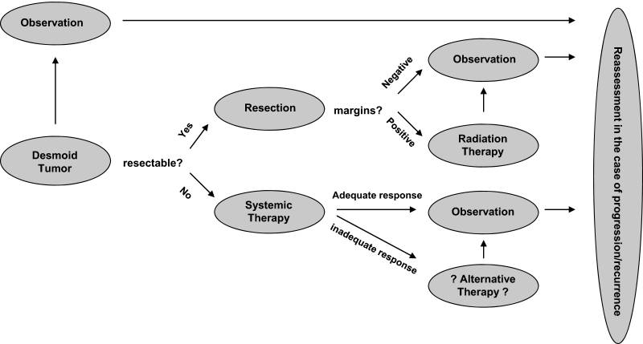

Figure 3: A treatment algorithm for desmoid tumors

Adapted from Lev et al. (Lev D, Kotilingam D, Wei C, et al. Optimizing treatment of desmoid tumors. J Clin Oncol. 2007;25:1785–1791).and Lazar et al. ( Lazar AJF, Hajibashi S, Lev D. Desmoid tumor: From surgical extirpation to molecular dissection. Curr Opin Oncol. 2009;21:352–359).University of Texas MD Anderson Cancer Center.



Figure 1: A 20-year old man; a huge desmoid tumor located in his neck region. (from [Toplu Y](https://www.ncbi.nlm.nih.gov/pubmed/?term=Toplu%20Y%5BAuthor%5D&cauthor=true&cauthor_uid=25513876), [Öztanır N](https://www.ncbi.nlm.nih.gov/pubmed/?term=%C3%96ztan%C4%B1r%20N%5BAuthor%5D&cauthor=true&cauthor_uid=25513876), [Çetinkaya Z](https://www.ncbi.nlm.nih.gov/pubmed/?term=%C3%87etinkaya%20Z%5BAuthor%5D&cauthor=true&cauthor_uid=25513876), [Koç A](https://www.ncbi.nlm.nih.gov/pubmed/?term=Ko%C3%A7%20A%5BAuthor%5D&cauthor=true&cauthor_uid=25513876), [Kızılay A](https://www.ncbi.nlm.nih.gov/pubmed/?term=K%C4%B1z%C4%B1lay%20A%5BAuthor%5D&cauthor=true&cauthor_uid=25513876). [Giant desmoid tumor in the neck]. [Kulak Burun Bogaz Ihtis Derg.](https://www.ncbi.nlm.nih.gov/pubmed/?term=y%C3%BCksel+toplu+desmoid) 2014 Sep-Oct;24(5):299-302.)



Figure 2: Photograps of the same patient after two months later (after surgery combined with radiotherapy) (from [Toplu Y](https://www.ncbi.nlm.nih.gov/pubmed/?term=Toplu%20Y%5BAuthor%5D&cauthor=true&cauthor_uid=25513876), [Öztanır N](https://www.ncbi.nlm.nih.gov/pubmed/?term=%C3%96ztan%C4%B1r%20N%5BAuthor%5D&cauthor=true&cauthor_uid=25513876), [Çetinkaya Z](https://www.ncbi.nlm.nih.gov/pubmed/?term=%C3%87etinkaya%20Z%5BAuthor%5D&cauthor=true&cauthor_uid=25513876), [Koç A](https://www.ncbi.nlm.nih.gov/pubmed/?term=Ko%C3%A7%20A%5BAuthor%5D&cauthor=true&cauthor_uid=25513876), [Kızılay A](https://www.ncbi.nlm.nih.gov/pubmed/?term=K%C4%B1z%C4%B1lay%20A%5BAuthor%5D&cauthor=true&cauthor_uid=25513876). [Giant desmoid tumor in the neck]. [Kulak Burun Bogaz Ihtis Derg.](https://www.ncbi.nlm.nih.gov/pubmed/?term=y%C3%BCksel+toplu+desmoid) 2014 Sep-Oct;24(5):299-302.)