26th October, 2016

Figure 1: Trend of rubella cases, congenital rubella syndrome (CRS), first and second dose of rubella-containing vaccine (RCV1, RCV2), Oman, 1985-2015

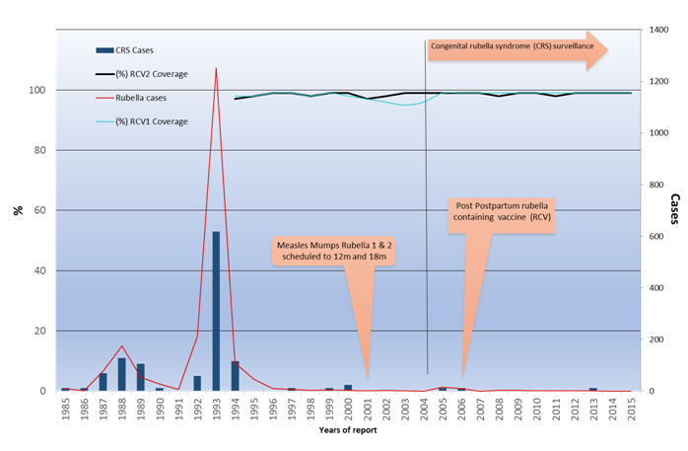

Figure 2: Congenital rubella syndrome (CRS) initial assessment form for general examination, Oman, 2015
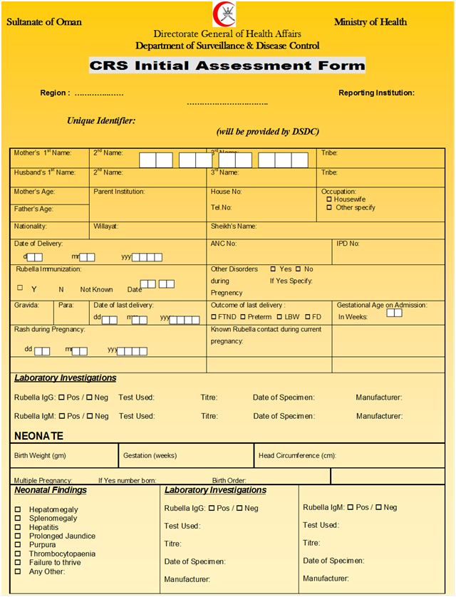

Figure 3: Congenital rubella syndrome (CRS) follow-up form for ocular and neurological manifestation, Oman, 2015
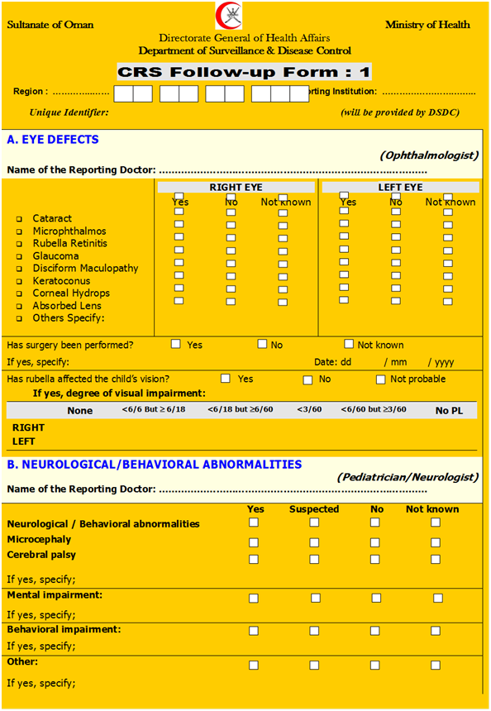
Figure 4: Congenital rubella syndrome (CRS) examination and data collection form for hearing and speech impairment, Oman, 2015
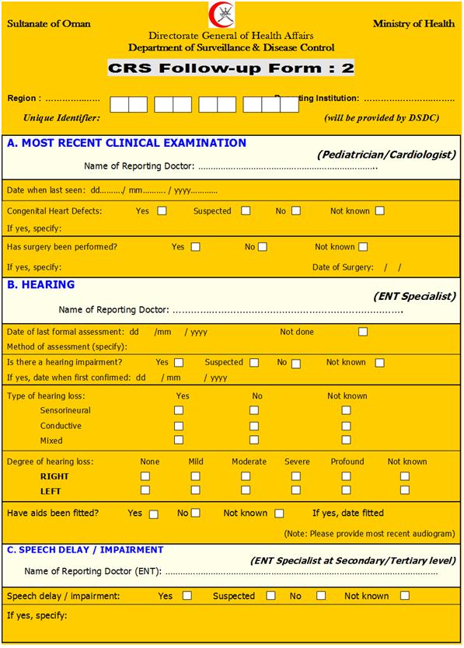

Figure 5. Congenital rubella syndrome (CRS) surveillance, Oman, 1980-2015
Source of CRS information are:
- National communicable disease surveillance
- Infant death registry
- Congenital anomalies and genetic disorders
- Eye and ENT diseases monthly report.
- Deafness monthly report
- Inpatient and outpatient monthly report

- Handicap centers.

104 CRS Suspected patients reported

85 (82%) CRS patients met the case definition

61 (72%) clinically confirmed CRS. All CRS patients were born during rubella outbreak period 1987- 1996
23 (27%) laboratory confirmed CRS

1 (1%) congenital rubella infection

46 (54%) CRS patients were evaluable and followed- up
(22, clinically confirmed; 23, laboratory confirmed; 1, congenital rubella infection)

20 (24%) Lost to follow-up
19 (22) Total death

Table 1. Congenital rubella syndrome (CRS) clinical manifestations identified upon diagnosis among evaluable patients, Oman, 1980-2015
Type of birth defect | Early clinical manifestations, incidence among evaluable CRS patients, No. (%)
Cardiovascular defect | 18 (39)
Congenital ocular defect | 29 (63)
Congenital cataract or glaucoma | 19 (41)
Congenital hearing impairment | 27 (59)
Microphthalmia | 7 (15)
Neurological defects | 25 (54)
Microcephaly | 24 (52)
Low birth weight(≤ 2.5Kg) | 11 (24)
Hepatosplenomegaly | 3 (6)
Purpura | -
Hypospadias* | 1 (2)
Unknown | -
Total evaluable CRS patients | 46
- Not included in CRS case definition

Table 2a. Causes of visual loss among evaluable congenital rubella syndrome patients upon diagnosis, Oman, 1980-2015
Type of ocular lost | No. (%)
Ocular Cataract | 14 (48)
Ocular cataracts one eye | 8 (57)
Ocular cataract both eyes | 6 (43)
Ocular glaucoma | 5 ( 29)
Ocular glaucoma one eye | 1(20)
Ocular glaucoma both eyes | 4 (80)
Retinitis | 16 (55)
Microphthalmos | 6 (21)
Aphakia | 3(10)
Corneal hydrops | 1 (3)
Hypermetropia | 1(3)
Keratoconus | 1 (3)
Absorbed lens | 1(3)
Eye surgery
Total surgeries | 20/60 (30)
Total ocular defects | 29

Table 2b. Causes of hearing lost among evaluable congenital rubella syndrome patients upon diagnosis, Oman, 1980-2015
Type of hearing lost | No. (%)
Reporting hearing lost both ears | 22 (81)
Sensorineural hearing impairment | 21 (78)
Conductive hearing impairment | 1 (4)
Mixed hearing impairment | 1 (4)
No ocular anomaly | 4 (15)
Speech impairment delay | 20 (74)
Use hearing device | 3 (11)
Unable to test for hearing loss | 3 (11)
Total hearing lost | 27

Table 2c. Cardiovascular system defects among evaluable congenital rubella syndrome patients upon diagnosis, Oman, 1980-2015
Defect | No. (%)
Patent ductus arteriosus (PDA) | 12 (66)
Ventricular septal defect (VSD) | 5 (28)
Organic systolic murmur | 3 (17)
Pulmonary stenosis | 1 (5)
Pulmonary atresia | 1 (5)
Total | 18

Table 2d. Neurological developmental defects among evaluable congenital rubella syndrome patients upon diagnosis, Oman, 1980-2015
Defect | No. (%)
Normal intelligence | 23 (50)
Microcephaly | 24 (52)
Mental retardation | 22(48)
Total CRS cases | 46

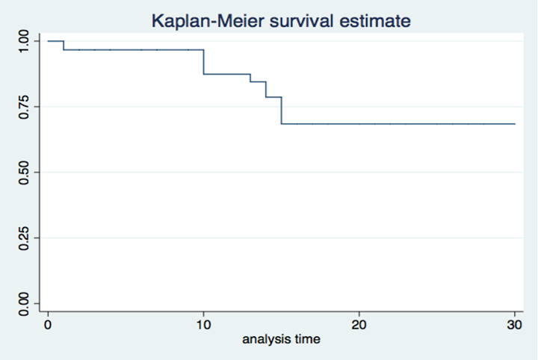Figure 6. Survival curse of all CRS cases, Oman, 1980-2015

