- research instruments
An analysis of literature has been conducted through Medline searching “Botulinum”, “masseter” and “bruxism”.

- figures and tables
figure 1 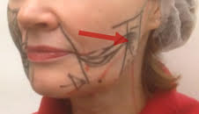figura2

figure3 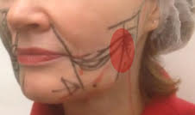

figura4

