Aspergillus pulmonary infection in cystic fibrosis patients –
more than just allergic bronchopulmonary aspergillosis

A 5-year retrospective study in a pediatric CF Population

Camilla Buch Kjølbye^{1,2}* & Tine Wrønding^{1,2}*, Christine Rønne Hansen¹, Marianne Skov¹
*Both authors equally contributed

¹Copenhagen CF Center, DBLC, Pediatric Dept. National University Hospital, Rigshospitalet, Copenhagen, Denmark.²The Faculty of Health Sciences, University of Copenhagen, Denmark
c.buch.t@gmail.com tinew85@gmail.com chistunte@dadlnet.dk mskov@dadlnet.dk

Corresponding author: Camilla Buch Kjølbye: Strandboulevarden 42, 4 floor, Copenhagen, +4528187186 c.buch.t@gmail.com

Abstract
Purpose of review: Among pediatric patients with cystic fibrosis (CF) the Aspergillus is commonly found in sputum causing various pulmonary infections. However, the prevalence and clinical impact is still unclear. The aim was to show prevalence of three Aspergillus pulmonary infections; Aspergillus bronchitis, allergic bronchopulmonary aspergillosis (ABPA) and invasive pulmonary aspergillosis (IPA) in the period 2007-2011 in a pediatric CF population (<18 years), and relate to gender, age and lung function.
Recent findings: Aspergillus pulmonary infections are a considerable problem among children with CF. Almost 40% of the CF children suffered from an Aspergillus pulmonary infection within the 5-year study period. Aspergillus bronchitis was the most common manifestation, seen from an early age and throughout childhood, whereas ABPA and IPA were rarely seen in children below 7 years of age. We found no difference in gender distribution when comparing the three diagnoses. In the majority of CF patients, lung function declined during an Aspergillus pulmonary infection.
Summery: Aspergillus pulmonary infections in CF patients under the age of 18 years are frequent and probably underestimated. The majority of patients with Aspergillus pulmonary infections experienced a decline in lung function.

Keywords: Cystic fibrosis, children, aspergillus bronchitis, allergic bronchopulmonary aspergillosis, invasive pulmonary aspergillosis

1. Introduction
The ubiquitous fungus Aspergillus is an increasingly important pathogen(Stevens, Moss, Kurup, & et, 2003) causing recurrent pulmonary exacerbations in cystic fibrosis (CF) patients. Defective mucociliary clearance results in local immunological disorders and antibiotic and corticosteroid therapy are factors potentially facilitating fungal growth(Latge, 1999; Wojnarowski, Eichler, Gartner, & et, 1997). Aspergillus fumigatus, most commonly associated with CF(Sabino, Ferreira, Moss, & et, 2014; Stevens et al., 2003), is isolated in up to 50% of sputum samples(Bakare, Rickerts, Bargon, & Just-Nubling, 2003) and increased levels of anti-A. fumigatus antibodies can be found in this population(Drazen, Gill, Griggs, & et, 2000). Deteriorating lung function occurs as a consequence of hypersensitivity or infection. The immunologic spectrum includes IgE-mediated sensitization (65%) (Maiz, Cuevas, Quirce, & et, 2002; Stevens et al., 2003) and allergic bronchopulmonary aspergillosis (ABPA) (10%). Whereas management of ABPA is well described (Amin, Dupuis, Aaron, & Ratjen, 2010), there are no randomized studies showing the effect of anti-inflammatory treatment in sensitized patients, although sensitization has been associated to lung function decline (Kraemer, Delosea, Ballinari, & et, 2006). The diagnosis and treatment of Aspergillus bronchitis (AB)(Baxter, Dunn, Jones, & et, 2013; Shoseyov, Brownlee, Conway, & Kerem, 2006) which contribute to local inflammatory response, and the more severe invasive pulmonary aspergillosis (IPA) causing invasion of the bronchial wall resulting in pneumonia, tracheobronchitis and pleural effusion(Brown, Rosenthal, & Bush, 1999; Chotirmall & McElvaney, 2014) is still debatable, non-standardized, and potentially underestimated. We present the prevalence of three A. fumigatus pulmonary manifestations in a pediatric CF population and relate these to age, gender and lung function.

2. Materials and methods

All pediatric CF patients (<18 years) in the Copenhagen CF Center were included in this descriptive, retrospective study within a 5-year period 2007-2011 (lung function data in Figure 2 expanded to 2014). Monthly control visits include clinical evaluation, spirometry and microbiological assessment of lower respiratory tract secretions, including Sabouraud media for fungal growth.
In case of clinical deterioration, bronchoscopy with bronchoalveolar lavage (BAL), including galactomannan (GM) test, was performed. Chest x-ray was performed yearly and during pulmonary exacerbation. Aspergillus-serology (total IgE, eosinophilic count, anti-A. fumigatus-IgG and anti-A. fumigatus-IgE) was performed at least annually and more frequently in A. fumigatus-positive patients or during exacerbation. Table 2 shows definition and criteria for AB, ABPA, and IPA. AB was diagnosed when a patient showed clinical deterioration, lack of response to anti-bacterial antibiotics, positive anti-A. fumigatus IgG and radiological changes, with A. fumigatus as the main pathogen, but without meeting criteria for ABPA(Shoseyov et al., 2006). IPA is defined as a diffuse pulmonary infection caused by A. fumigatus with invasion of the bronchial wall, but no systemic infection. Diagnostic criteria include: Positive anti-A. fumigatus IgG antibodies, positive GM in BAL fluid (>1(ng/ml)), changes on CT scan, hemoptysis, possibly histopathology, and pulmonary exacerbation with response to intravenous anti-fungal therapy(Brown et al., 1999; Kosmidis & Denning, 2015). In the present study we did not include patients with Aspergillus hypersensitivity.
The prevalence of the three different Aspergillus pulmonary infections was calculated and each Aspergillus manifestation was related to age, gender and lung function. Data was collected from the patient files and the CF-database at the Copenhagen CF Center
All patients were evaluated for development of chronic, pulmonary Pseudomonas aeruginosa infection using the “Leeds’ criteria”(Lee, Brownlee, Conway, & et, 2003), and excluded at time of development of chronic infection.
Patients without A. fumigatus infection were included as a control group. Mean values of FEV1, % predicted, for all three aspergillus groups were compared over a 6-year period around the time of diagnosis, corresponding to time of treatment-initiation.

2.1. Statistics: All collected data was included in the analysis. Graphs were made using Excel and SPSS.

3. Results

One hundred and six CF patients (<18 years) were included, median age 9 years (range 0-17). No significant gender difference was found (Table 1).Forty percent of the included patients were diagnosed with one of the three A. fumigatus pulmonary infections. Aspergillus bronchitis was the most common infection, including 28% of the patients. Eight percent were diagnosed with ABPA, and 5% with IPA. One patient was diagnosed with both ABPA and IPA within the study period. Sixty percent were not identified with any Aspergillus pulmonary infection during the 5-year period (Table 1). Figure 1 shows the average age at debut of aspergillus disease and gender in the three different aspergillus groups. The risk of acquiring AB was present from the age of 2 years (except one patient) (Figure 1 and Table 1) and has the widest age span. No patients were diagnosed with ABPA or IPA before the age of 7 years. Patients in the control group include all ages.
Figure 2 shows average FEV1% of predicted for all three aspergillus groups over a 6-year period three years prior to, at infection start and three years post infection debut. A lung function decline was seen at time of diagnosis, and lung function increased immediately after initiation of anti-fungal treatment. Only the ABPA group showed sustained improvement.
The non-aspergillus group had the highest level of FEV1% predicted (mean 90%), whereas all patients in the A. fumigatus groups had generally lower FEV1; ABPA 88%, AB 85%, IPA 83% (data not shown).
No difference in pancreatic insufficiency was found among groups (Table 1).

4. Discussion

Surprisingly as much as forty percent of our pediatric CF population was diagnosed with an aspergillus pulmonary infection. Most patients (28%) were diagnosed with AB, which is comparable to the 30% prevalence shown in an adult CF population using positive real-time PCR, elevated A. fumigatus-IgG and positive sputum GM as diagnostic criteria(Drazen et al., 2000). Adding total and specific IgE as specific markers, the same criteria was suggested for ABPA and was seen in 17.7% of the CF population in New Zealand(Baxter et al., 2013). Shosevoy et al. presented 6 cases of adolescent and young adult CF patients with AB, using inappropriate response to anti-bacterial but positive response to anti-fungal antibiotics and positive A. fumigatus sputum culture as diagnostic criteria, and furthermore excluding ABPA (11) i.e. similar criteria as used in the present study. We diagnosed 8% of the patients with ABPA, which is in accordance with the majority of studies demonstrating a prevalence of ABPA of 10%(Baxter et al., 2013; Chmiel, Aksamit, Chotirmall, & et, 2014; Mastella, Rainisio, Harms, & et, 2000).In some patients symptoms were of a more serious character than AB, but without the hypersensitivity reaction as seen in ABPA. These patients were diagnosed as having IPA: i.e. symptoms of hemoptysis and pulmonary exacerbation, but with response to intravenous anti-fungal therapy(Brown et al., 1999; Kosmidis & Denning, 2015). Invasive pulmonary aspergillosis clearly differs from systemic invasive aspergillosis, commonly found in immune-compromised patients with extra-pulmonary involvement. Although rarely described in CF(Kosmidis & Denning, 2015), we found five patients fulfilling criteria for IPA during the 5-year-period. None of them had fatal outcome as described in other studies(Brown et al., 1999; Massam, Bitnun, Solomon, & et, 2011; Mosquera, Estrada, Clements, & Jon, 2013).
Our results suggest that all three aspergillus pulmonary manifestations have a negative impact on FEV1, which is comparable to previous findings(Amin et al., 2010). The results may be confounded by other lung infections, however patients having chronic P. aeruginosa lung infection were excluded. Patients with ABPA seem to response slightly better to treatment. . Earlier diagnosis, due to recognized diagnostic criteria (Chmiel et al., 2014)leading to earlier treatment may in part be the explanation. No significant difference in FEV1 between groups was found, probably due to the low number of patients.
Although patients in our clinic are routinely assessed for A. fumigatus infection, including measurement of anti-A. fumigatus IgE antibodies, sensitization is not considered a common problem in this cohort of patients, in contrast to the other aspergillus pulmonary manifestations. These patients were consequently not included in this study.
The increasing number of pathogens found in the united airways of patients with CF over the last decades and thus greater consumption of antibiotics might favor fungal infections.
The consensus guidelines are more than a decade old, and while useful for ABPA, these criteria do not embrace management of other A. fumigatus pulmonary manifestations in CF.

5. Conclusion

In conclusion, Aspergillus pulmonary infection - not only ABPA - has a negative impact on lung function and starts early in CF life. Awareness even among the youngest is suggested and improved diagnostic criteria and treatment strategies in aspergillus pulmonary diseases other than ABPA are needed.

Table 1
 | N=(% of all patients) | Females  N= (median years)  (range years)  (% of all patients) | Males  N= (median years)  (range years)  (% of all patients) | Homozygous for delta F508/  heterozygous for delta  F508/other | PI/PS
Aspergillus Bronchitis | 30 (28%) | 14 (7)( 2-16 )(13%) | 16 (10)( 0-17 )(15%) | 15/12/3 | 25/5
ABPA | 8 (8%) | 4 (12.5)( 7-13 )(4%) | 4 (12.5)( 11-16 )(4%) | 5/2/0 | 7/0
Invasive Pulmonary Aspergillosis | 5 (5%) | 3 (13) (10-15 )(3%) | 2 (12)( 8-16 )(2%) | 3/2/0 | 5/0
Non-aspergillus-controls | 64 (60%) | 31(7)( 0-17 )(29%) | 33 (10)( 0-17 )(31%) | 34/19/11 | 55/9
Distribution of gender, and pancreas-insufficiency of the three different Aspergillus pulmonary infections and patients without Aspergillus infections (non-aspergillus)

Note that 1 patient has both ABPA and IPA during the 5-year period from 2007-2011.

Figure 1
Box plot of average age at debut of A.fumigatus disease in the three different pulmonary infections according to gender

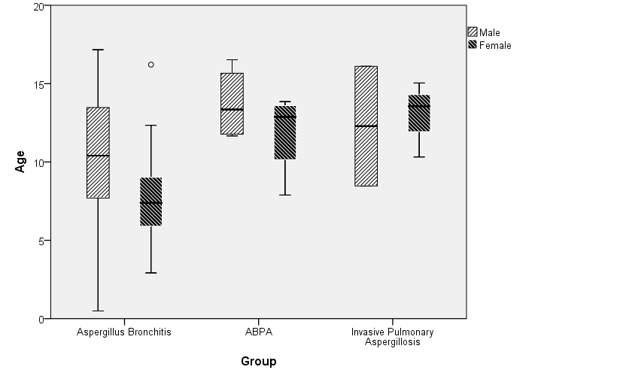

Figure 2
FEV1% for all 3 Aspergillus pulmonary infections at the point of diagnosis, 3 years prior and 3 years after this point

Table 2
Definition and criteria for aspergillus bronchitis, allergic bronchopulmonary aspergillosis and invasive pulmonary aspergillosis
 | Aspergillus bronchitis | ABPA  (Allergic Bronchopulmonary Aspergillosis) | IPA  (Invasive Pulmonery Aspergillosis)
Definition | A lung infection where Aspergillus is considered the potential pathogen.  It may possibly in part be an early stage of ABPA(Shoseyov et al., 2006) | A combined hypersensitivity reaction with increased specific anti-Aspergillus IgG and –IgE antibodies, eventually leading to bronchiectasis and fibrosis (1) | A diffuse infection in the lung where the bronchial wall is invaded by Aspergillus leading to invasive pulmonary aspergilosis, but without invasion of systemic circulation (invasive aspergillosis)(Chotirmall, Al-Alawi, Mirkovic, & et, 2013)
Diagnostic criteria
Symptoms | 1)Acute or sub-acute clinical deterioration with  - cough  - increased sputum production  - decline in lung function  - lack of response to antibacterial antibiotics  (Shoseyov et al., 2006) | 1) Clinical deterioration (1)  - cough  - wheeze  - exercise  - intolerance  - exercise-induced asthma,  - decrease in lung function, or  - increased sputum production) | 1) Dry cough, dyspnea, chest pain, fever and pulmonary infiltrates despite antibiotic treatment.  2) Hemoptysis and decrease in lung function.  3) Lack of response to oral anti-fungal therapy, but positive response to iv. anti-fungal therapy.
Serology | 2) Positive sputum cultures for Aspergillus but not positive criteria for ABPA(1).  3) Specific Aspergillus- IgG may be elevated. | 2) Elevated total serum IgE>500 IU/ml  3) Immediate cutaneous reactivity to Aspergillus species or elevated serum anti-Aspergillus-IgE  4) Serum precipitating antibodies against Aspergillus or specific anti-Aspergillus-IgG | 4) Positive Aspergillus in sputum or bronchoalveolar lavage fluid (BAL)  5) Positive galactomannan (GM) in BAL fluid (>1(ng/ml))  6) Anti-Aspergillus IgG-antibodies
Radiology | 4) Radiological findings with  - infiltrates,  - atelectasis and  - bronchiectases  on chest X-ray and CT scan are seen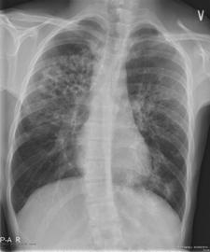. | 5) Radiological findings are  - Chest X-ray infiltrates, current or in the past,  - mucus plugging or  - chest CT-scan with central bronchie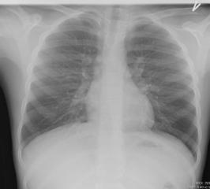 | 7) Radiological findings are  - lung infiltrates,  - pneumonia or  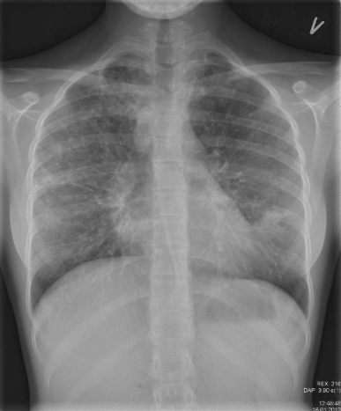  - lung abscesses
Others/  Comments | It is likely that the A.fumigatus causes bronchitis without an allergic response. | Minimal diagnostic criteria for ABPA in CF patients include:  Criteria 1, 2 (– but total serum IgE> 500 IU/ml), 3and 4 or 5. | 8) Additional criteria is a decline in lung function due to Aspergillus (i.e. bacterial infection as cause of exacerbation has been excluded)  Possibly histopathology, and pulmonary exacerbation with response to intravenous anti-fungal therapy(Brown et al., 1999; Kosmidis & Denning, 2015)  Criteria described above are in part based on local center guidelines

References:
Amin, R., Dupuis, A., Aaron, S. D., & Ratjen, F. (2010). The effect of chronic infection with Aspergillus fumigatus on lung function and hospitalization in patients with cystic fibrosis. Chest, 137(1), 171-176. doi: 10.1378/chest.09-1103
Bakare, N., Rickerts, V., Bargon, J., & Just-Nubling, G. (2003). Prevalence of Aspergillus fumigatus and other fungal species in the sputum of adult patients with cystic fibrosis. Mycoses, 46(1-2), 19-23.
Baxter, C. G., Dunn, G., Jones, A. M., & et, a. l. (2013). Novel immunologic classification of aspergillosis in adult cystic fibrosis. J Allergy Clin Immunol, 132(3), 560-566 e510. doi: 10.1016/j.jaci.2013.04.007
Brown, K., Rosenthal, M., & Bush, A. (1999). Fatal invasive aspergillosis in an adolescent with cystic fibrosis. Pediatr Pulmonol, 27(2), 130-133.
Chmiel, J. F., Aksamit, T. R., Chotirmall, S. H., & et, a. l. (2014). Antibiotic management of lung infections in cystic fibrosis. II. Nontuberculous mycobacteria, anaerobic bacteria, and fungi. Ann Am Thorac Soc, 11(8), 1298-1306. doi: 10.1513/AnnalsATS.201405-203AS
Chotirmall, S. H., Al-Alawi, M., Mirkovic, B., & et, a. l. (2013). Aspergillus-associated airway disease, inflammation, and the innate immune response. Biomed Res Int, 2013, 723129. doi: 10.1155/2013/723129
Chotirmall, S. H., & McElvaney, N. G. (2014). Fungi in the cystic fibrosis lung: bystanders or pathogens? Int J Biochem Cell Biol, 52, 161-173. doi: 10.1016/j.biocel.2014.03.001
Drazen, Gill, Griggs, & et, a. l. (2000). Cecil Textbook of Medicine. 401-405.
Kosmidis, C., & Denning, D. W. (2015). The clinical spectrum of pulmonary aspergillosis. Thorax, 70(3), 270-277. doi: 10.1136/thoraxjnl-2014-206291
Kraemer, R., Delosea, N., Ballinari, P., & et, a. l. (2006). Effect of allergic bronchopulmonary aspergillosis on lung function in children with cystic fibrosis. Am J Respir Crit Care Med, 174(11), 1211-1220. doi: 10.1164/rccm.200603-423OC
Latge, J. P. (1999). Aspergillus fumigatus and aspergillosis. Clin Microbiol Rev, 12(2), 310-350.
Lee, T. W., Brownlee, K. G., Conway, S. P., & et, a. l. (2003). Evaluation of a new definition for chronic Pseudomonas aeruginosa infection in cystic fibrosis patients. J Cyst Fibros, 2(1), 29-34. doi: 10.1016/s1569-1993(02)00141-8
Maiz, L., Cuevas, M., Quirce, S., & et, a. l. (2002). Serologic IgE immune responses against Aspergillus fumigatus and Candida albicans in patients with cystic fibrosis. Chest, 121(3), 782-788.
Massam, J., Bitnun, A., Solomon, M., & et, a. l. (2011). Invasive aspergillosis in cystic fibrosis: a fatal case in an adolescent and review of the literature. Pediatr Infect Dis J, 30(2), 178-180. doi: 10.1097/INF.0b013e3181f63c90
Mastella, G., Rainisio, M., Harms, H. K., & et, a. l. (2000). Allergic bronchopulmonary aspergillosis in cystic fibrosis. A European epidemiological study. Epidemiologic Registry of Cystic Fibrosis. Eur Respir J, 16(3), 464-471.
Mosquera, R. A., Estrada, L., Clements, R. M., & Jon, C. K. (2013). Early diagnosis and treatment of invasive pulmonary aspergillosis in a patient with cystic fibrosis. BMJ Case Rep, 2013. doi: 10.1136/bcr-2013-201360
Sabino, R., Ferreira, J. A., Moss, R. B., & et, a. l. (2014). Molecular epidemiology of Aspergillus collected from cystic fibrosis patients. J Cyst Fibros. doi: 10.1016/j.jcf.2014.10.005
Shoseyov, D., Brownlee, K. G., Conway, S. P., & Kerem, E. (2006). Aspergillus bronchitis in cystic fibrosis. [Case Reports]. Chest, 130(1), 222-226. doi: 10.1378/chest.130.1.222
Stevens, D. A., Moss, R. B., Kurup, V. P., & et, a. l. (2003). Allergic bronchopulmonary aspergillosis in cystic fibrosis--state of the art: Cystic Fibrosis Foundation Consensus Conference. Clin Infect Dis, 37 Suppl 3, S225-264. doi: 10.1086/376525
Wojnarowski, C., Eichler, I., Gartner, C., & et, a. l. (1997). Sensitization to Aspergillus fumigatus and lung function in children with cystic fibrosis. Am J Respir Crit Care Med, 155(6), 1902-1907.

